Auto-ID Middleware

Auto-ID Middleware
High Level Design Document
Document Version 1.0

2004-12-24

Auto-ID Middleware
High Level Design Document

Revision History
Version | Date | Author | Remarks
1.0 | 2004/12/24 |  | Initial Version

Web Console

登陆界面
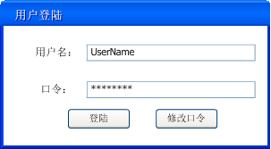
Login.jsp
登陆 用户名与口令分别在Users表中进行验证（ExternalUser用户不允许登陆），登陆成功进入main.jsp页面，用户的Role和可控制的DeviceList保存到Session中，登陆后的所有页面都会根据session中的信息来控制用户的访问权限
修改口令进入ChangePwd.jsp

Loign.jsp这页面数据需要通过Https SSLl 128通讯.

创建加密证书文件ubipass.keystore,输入公司的用户信息和密码等.
%JAVA_HOME%\bin\keytool -genkey -alias tomcat -keyalg RSA –keystore ubipass.keystore

配置TOMCAT5.5 的Server.xml文件

<Connector port="8443"
maxThreads="150"
minSpareThreads="25"
maxSpareThreads="75"
enableLookups="false"
disableUploadTimeout="true"
acceptCount="100"
scheme="https"
secure="true"
clientAuth="false"
sslProtocol="TLS"
keystoreFile="ubipass.keystore"
keystorePass="123456"
/>

keystoreFile 的证书的地址:默认放在$TOMCAT_HOME目录下

指定Login.jsp页面加密通讯

<security-constraint>
<web-resource-collection>
<web-resource-name>pass by ssl</web-resource-name>
<url-pattern>/login.jsp</url-pattern>
<url-pattern>/ChangePwd.jsp</url-pattern>
<http-method>POST</http-method>
<http-method>GET</http-method>
</web-resource-collection>
<user-data-contraint>
<transport-guarantee>CONFIDENTIAL</transport-guarantee>
</user-data-contraint>
</security-constraint>

WEB用户验证我们将采用系统自带的j_security_check进行验证
配置TOMCAT5.5 的Server.xml文件

<Realm className="org.apache.catalina.realm.JDBCRealm" debug="99"
driverName="org.gjt.mm.mysql.Driver"
ConnectionURL="jdbc:mysql://192.168.0.1/middleware?user=root&amp;password=1"
Digest=”MD5” //经过md5加密
userTable="users"
userNameCol="userName"
userCredCol="passwd"
userRoleTable="roles"
roleNameCol="roleType"
/>

用户的密码是经过MD5加密.

关于用户密码验证成功及失败跳转.
配置web.xml 放在/middleware/WEB-INF/web.xml

<web-app>
<!-- Login configuration uses form-based authentication -->
<login-config>
<auth-method>FORM</auth-method>
<realm-name>middleware Form-Based Authentication Area</realm-name>
<form-login-config>
<form-login-page>/login.jsp</form-login-page>
<form-error-page>/login.jsp</form-error-page>//验证失败将会跳到此页面
</form-login-config>
</login-config>
</web-app>

如果验证成功了,将跳转到Index.jsp并得到所登录的用户.request.getRemoteUser()
和DB Pooling 读出此用户所管理的Reader并加入到list中,并把ReaderList存入到Session中

<%@ page import="java.util.*"%>
<%@ page import="java.sql.*"%>
<%@ page import="com.ubipass.middleware.exception.NotConnectException"%>
<%@ page import="com.ubipass.middleware.util.DBConnPool"%>
<%
String loginUsername = request.getRemoteUser();
if(loginUsername != null && !loginUsername.equals("") && session.getAttribute("readers")== null){
try {
Connection conn = DBConnPool.getConnection();
Statement s = conn.createStatement();
ResultSet resultUser = s.executeQuery("select id from users where userName='"+ loginUsername + "'");
if(resultUser.next()){
ResultSet resultReader = s.executeQuery("select readers.readerid from userreader,readers where userreader.readerid=readers.id and userid="+ resultUser.getInt(1));
List readers= new ArrayList();
while(resultReader.next()){
readers.add(resultReader.getString(1));
}
session.setAttribute("readerList",readers);
}else{
out.println("NO Readers");
}
conn.close();
} catch (NotConnectException e) {
out.println(e.getMsg());
} catch (SQLException e) {
out.println("SQLException");
}
}
%>

此程序是将用户和Device存入session 通过DBPooling

关于Administrator, Viewer, Operator 的权限分配
<web-app>
…………………
<security-constraint>
<web-resource-collection>
<web-resource-name>about Role Viewer </web-resource-name>
<url-pattern>/login.jsp</url-pattern>
<url-pattern>/Main.jsp</url-pattern>
<url-pattern>/TreeMenu.jsp</url-pattern>
<url-pattern>/ChangePwd.jsp</url-pattern>
<url-pattern>/index.jsp</url-pattern>
<url-pattern>/tag/TagList.jsp</url-pattern>
<http-method>POST</http-method>
<http-method>GET</http-method>
</web-resource-collection>
<auth-constraint>
<!-- Anyone with one of the listed roles may access this area -->
<role-name>Viewer</role-name>
</auth-constraint>
</security-constraint>
<security-constraint>
<web-resource-collection>
<web-resource-name>about Role Operator </web-resource-name>
<url-pattern>/login.jsp</url-pattern>
<url-pattern>/Main.jsp</url-pattern>
<url-pattern>/TreeMenu.jsp</url-pattern>
<url-pattern>/ChangePwd.jsp</url-pattern>
<url-pattern>/index.jsp</url-pattern>
<url-pattern>/reader/ReaderList.jsp</url-pattern>
<url-pattern>/tag/TagList.jsp</url-pattern>
<http-method>POST</http-method>
<http-method>GET</http-method>
</web-resource-collection>
<auth-constraint>
<role-name>Operator</role-name>
</auth-constraint>
</security-constraint>
<security-constraint>
<web-resource-collection>
<web-resource-name>About role administrator</web-resource-name>
<url-pattern>/*</url-pattern>
<http-method>POST</http-method>
<http-method>GET</http-method>
</web-resource-collection>
<auth-constraint>
<role-name>Administrator</role-name>
</auth-constraint>
</security-constraint>
<web-app>

修改口令
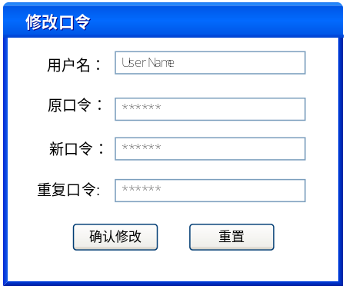
ChangePwd.jsp
确认修改成功后提示，并修改Users表的passwd字段，并跳转到login.jsp,失败则提示失败
重置 将原口令,新口令,重复口令置空

主页
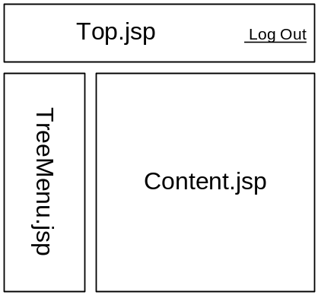
Main.jsp
Top.jsp放Logo，Caption及LogOut按钮

菜单
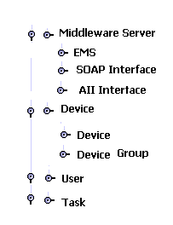
TreeMenu.jsp

DeviceGroup管理
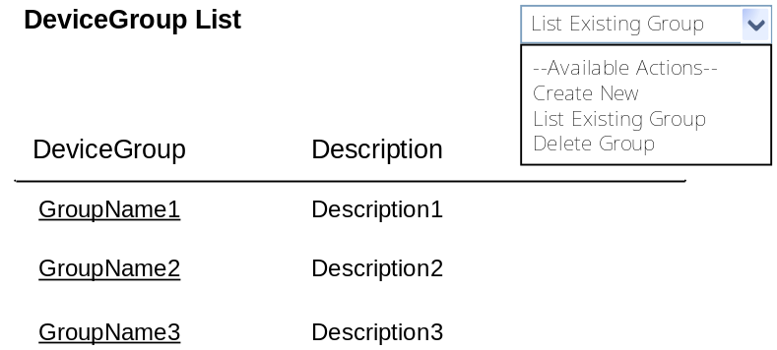
ListDeviceGroups.jsp

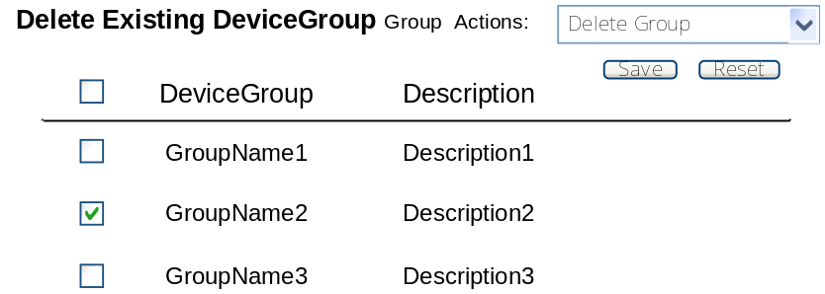
DeleteDevices.jsp
Device组管理页面（Administrator访问）
读取Groups表，列出DeviceGroup，按组名排序
单击DeviceGroup进入AddDeivceGroup.jsp
Save删除选择的Group，删除时给提示
Reset重新选择
Create New添加一个新组进入AddDeviceGroup.jsp

Device组编辑
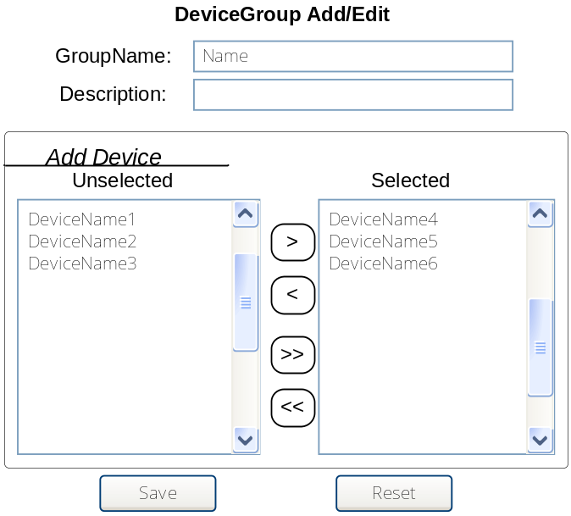
AddDeviceGroup.jsp
Device组编辑页面（Administrator访问）
GroupName给组命名，必须填写，否则在Save时提示填写
Description输入描述
Add Device分配Device ，Selected中是DeviceGroup中已经绑定的Device，Unselected是其他的Device
Save GroupName和Description将分别保存至Groups表，AddDevice的Selected部分的信息保存到DeviceGroup表中，然后跳转到ListDeviceGroups.jsp
Reset重新配置

Device管理
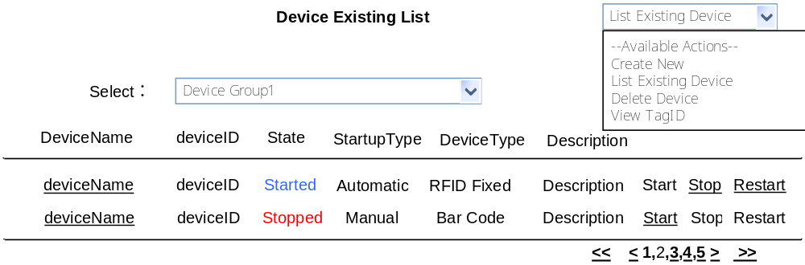
ListDevices.jsp
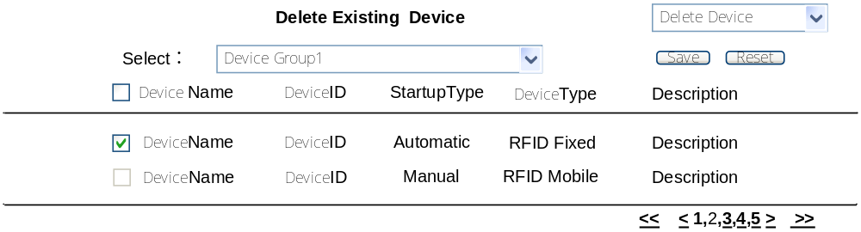
DeleteDevices.jsp
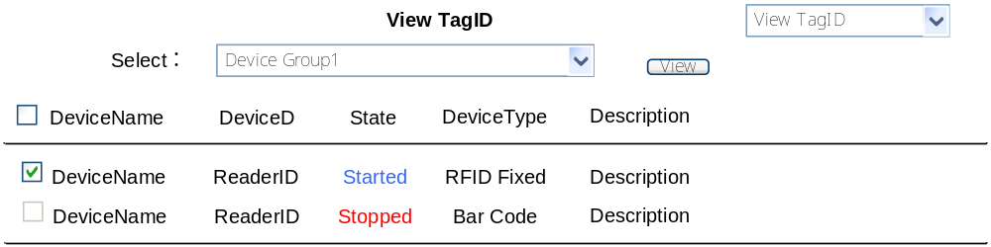
ViewDevicesEPC.jsp
可选择特定的Group,显示其中的Device列表,也可以选择（ALL）所有的Device
Start/Stop/Restart管理Device的启动关闭(Administrator和Operator可以操作)
当State为start时，可以Stop/Restart操作
当State为stop时，可以Start操作，并将状态写入Devices表的status
单击DeviceName编辑Device的属性，进入AddDevice.jsp（只有Administator可以操作）
View根据选定的Device显示所读到的TagID，进入ListTags.jsp（都可操作）
Create New新建一个Reader，进入AddDevice.jsp（只有Administator可以操作），支持分页显示
Save删除选定的Device，给出提示，同时删除Device所对应的外键
Reset重新选择

Device 编辑
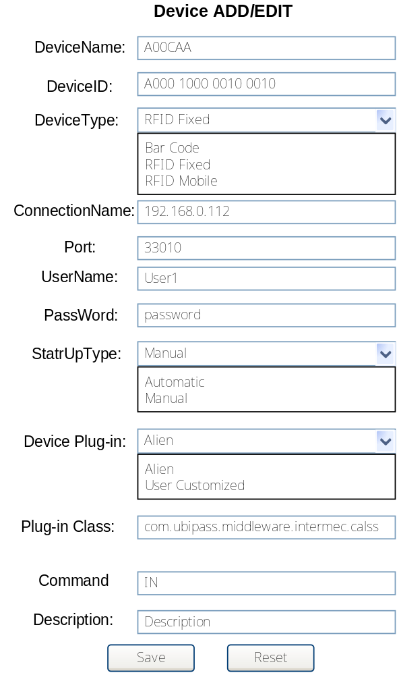
AddDevice.jsp
设置device的具体属性(Administator可访问)
device Plug-in中选择User Customized时，要求输入Plug-in Class中输入对应的Plug-in class的全路径类名
Save将信息保存至Devices表，当Device Plug-in选择User Customized时，将Plug-in Class输入的信息保存到class字段，如果选择了其他的就将plugins表的对应Class保存到class字段，并跳转到ListDevices.jsp
Reset重新读取原来配置

显示TagID码
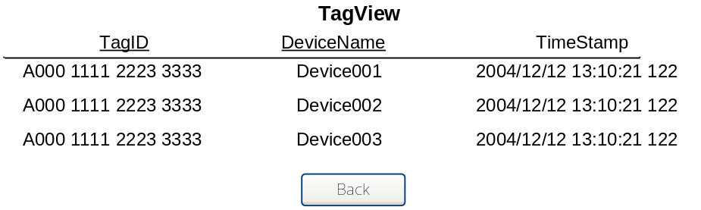
ListTags.jsp

User管理
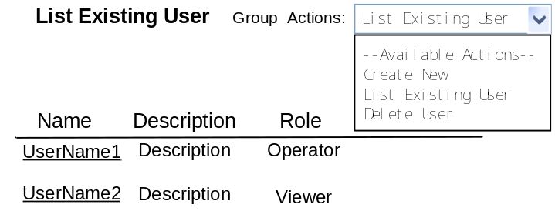
ListUsers.jsp
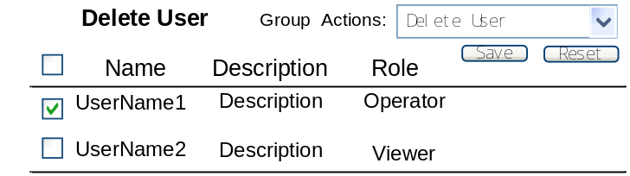
DeleteUsers.jsp
用户管理里页面（Administrator访问）
单击UserName对用户进行编辑，进入AddUser.jsp
Save删除选择User给用户提示，同时该用户可以管理的Device的外键
Create New添加用户，进入AddUser.jsp

编辑用户
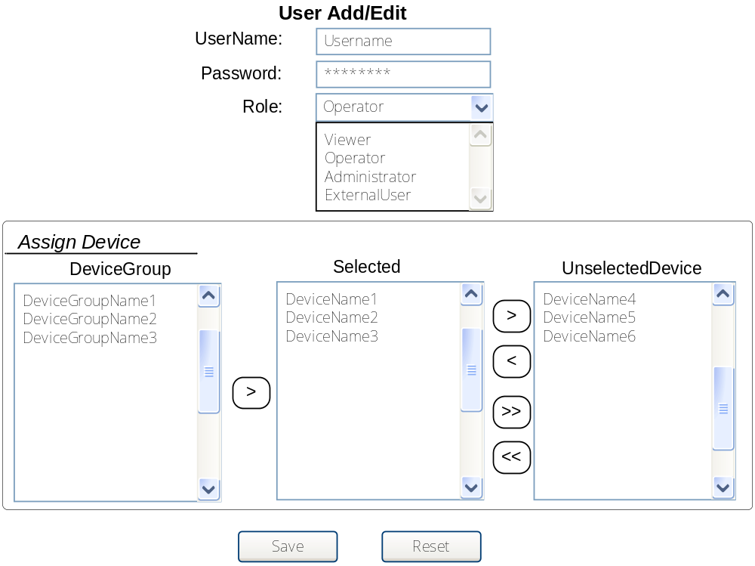
AddUser.jsp
AssignReader给用户分配其可管理的Device
Selected中显示UserDevice表中的信息，选DeviceGroup中的组后会在Selected中添加该组中没有被添加的的Device，同时Unselected中也会减少相应的Device。
Save保存到Users表，将Selected中的Reader保存到UserDevice表中，然后跳转到ListDevices.jsp
Reset重新读取原来配置

配置EMS的属性
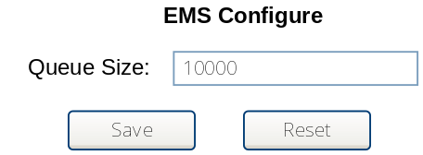
ConfigureEMS.jsp
Save保存至EMS表，Reset重新读取原来配置

列出Task表中的Task
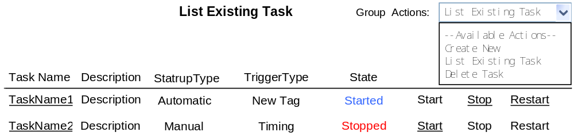
ListTasks.jsp
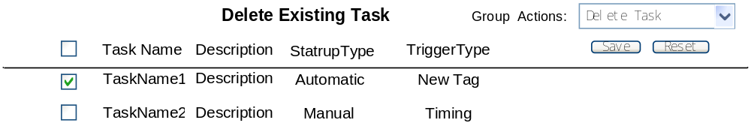DeleteTasks.jsp
(Administrator可以操作)
Start/Stop/Restart管理Task的启动关闭重新启动：当State为start时，可以Stop/Restart操作；当State为stop时，可以Start操作;操作成功修改Tasks表的status字段。
点击TaskName编辑Task 将跳转到AddTask.jsp
Save 删除选择的Task ，给出提示
Create New跳转到AddTask.jsp
Reset重新选择Task

编辑Task
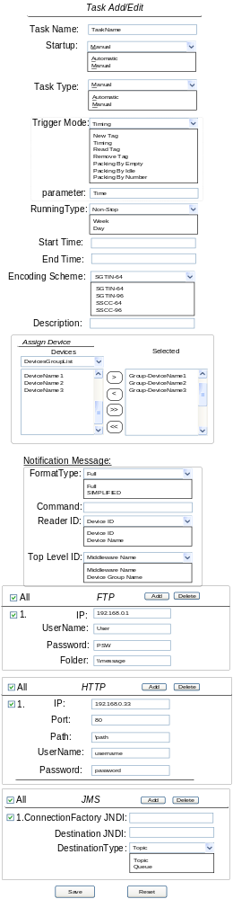
TaskEdit.jsp
当Trigger选择Timing和Package Moving By Idle时将提示输入Time
Tigger当选择Timing时，要定义定时间隔（单位毫秒）；当选择Package Moving By Idle时，要定义空闲间隔（相邻托盘通过Reader最小时间间隔），都在Time里输入。
AssignReader给Task分配Reader
Selected中显示TaskReader表中的信息，选ReaderGroup中的组后会在Selected中添加该组中没有被添加的的Reader，同时Unselected中也会减少相应的Reader。
4种接口在选择数量后就可以分别编辑，但总数不能超过10个，如超过10个在提交时给提示
Save保存到Tasks表，Selected中的Reader将保存到TaskReader表中，4种接口分别保存到对应的表中，并跳转到TaskList.jsp
Reset重新读取原来配置

配置Aii Interface
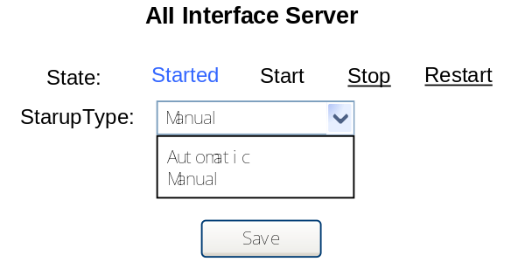
AiiCfg.jsp
修改AiiInterface表

配置SOAP Interface
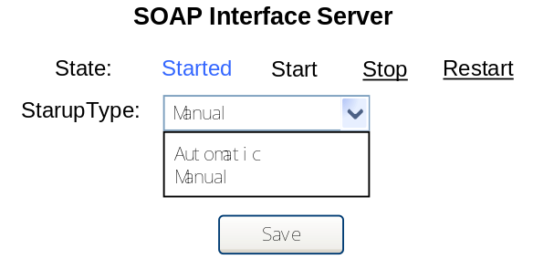
SOAPCfg.jsp
修改SOAPInterface表

写Tag
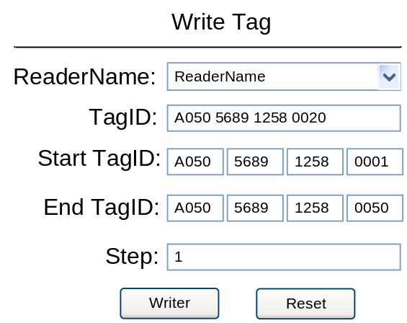
WriteTag.jsp
用指定的Reader向Tag写入TagID
ReaderName选择系统中的Reader
Start TagID输入16位的ID号,用于写入Tag的起始ID
End TagID输入16位的ID号,用于写入Tag的结束ID
TagID 表示当前写入的ID
Step 一次写完Tag后TagID自动累加的步长
Write检查TagID的有效性,然后写Tag
Reset 清空TagID, Start TagID, End TagID

Internationalization
所有Web页面都要支持internationalization，根据Web Client的Locale设置自动选择语言显示。初始配置支持中文(ZH-CN)和英文(EN)。
对每种支持的Locale，准备编辑对应的资源文件放入目录WEB-INF/classes/下：
文件名的定义: 自定义名字+区域(en,zh_CN)+.properties

welcome_en.properties (英文资源文件)
Login.title=welcome to login
Login.username = username
Login.password = password

welcome_zh_CN.properties (中文资源文件)
Login.title=欢迎登录
Login.username = 用户名
Login.password = 密码

注意：对中文的properties文件，必须使用Native2ascii –encoding工具把GB2312转化成GBK, Tomcat方能正确显示：
Native2ascii –encoding GBK welcome_zh_CN.properties welcome_zh_CN.properties

例如welcome.jsp：

<%@ taglib prefix="fmt" uri="http://java.sun.com/jsp/jstl/fmt" %>
<fmt:bundle basename=”welcome”> //此值是指的资源文件名
<html>
<head>
<title><fmt:message key=”Login.title” /></title>
</head>
<body>
<fmt:message key=”Login.username” /></br>
<fmt:message key=”Login.password” />
</body>
</html>

DB Pooling

JDBC DataSource Configuration for Mysql
First configure JNDI DataSource in middleware Context in $CATALINA_HOME/conf/server.xml, add <Resource> element in middleware Context to specify JDBC connection properties:
<Context path="/middleware" docBase="middleware"
debug="5" reloadable="true" crossContext="true">

<!-- maxActive: Maximum number of dB connections in pool. Make sure you
configure your mysqld max_connections large enough to handle
all of your db connections. Set to 0 for no limit.
-->

<!-- maxIdle: Maximum number of idle DB connections to retain in pool.
Set to -1 for no limit. See also the DBCP documentation on this
and the minEvictableIdleTimeMillis configuration parameter.
-->

<!-- maxWait: Maximum time to wait for a dB connection to become available
in ms, in this example 10 seconds. An Exception is thrown if
this timeout is exceeded. Set to -1 to wait indefinitely.
-->

<!-- username and password: MySQL dB username and password for dB connections -->

<!-- driverClassName: Class name for the old mm.mysql JDBC driver is
org.gjt.mm.mysql.Driver - we recommend using Connector/J though.
Class name for the official MySQL Connector/J driver is com.mysql.jdbc.Driver.
-->

<!-- url: The JDBC connection url for connecting to your MySQL dB.
The autoReconnect=true argument to the url makes sure that the
mm.mysql JDBC Driver will automatically reconnect if mysqld closed the
connection. mysqld by default closes idle connections after 8 hours.
-->

<Resource name="jdbc/middlewareDB" auth="Container" type="javax.sql.DataSource"
maxActive="100" maxIdle="30" maxWait="10000"
username="userName" password="password" driverClassName="com.mysql.jdbc.Driver"
url="jdbc:mysql://localhost:3306/middleware?autoReconnect=true"/>

</Context>

Second define one <resource-ref> elment in web.xml under /WEB-INF of middleware.war which is deployed under $CATALINA_HOME/webapps.

<web-app xmlns="http://java.sun.com/xml/ns/j2ee"
xmlns:xsi="http://www.w3.org/2001/XMLSchema-instance"
xsi:schemaLocation="http://java.sun.com/xml/ns/j2ee
http://java.sun.com/xml/ns/j2ee/web-app_2_4.xsd"
version="2.4">
<description>Ubipass AutoID Middleware</description>
<resource-ref>
<description>DB Connection</description>
<res-ref-name>jdbc/middlewareDB</res-ref-name>
<res-type>javax.sql.DataSource</res-type>
<res-auth>Container</res-auth>
</resource-ref>
</web-app>

JDBC DataSource Configuration for Oracle
Tomcat server.xml

<Resource name="jdbc/middlewareDB" auth="Container"
type="javax.sql.DataSource" driverClassName="oracle.jdbc.driver.OracleDriver"
url="jdbc:oracle:thin:myschema@127.0.0.1:1521:mysid"
username="userName" password="password" maxActive="20" maxIdle="10"
maxWait="-1"/>

Middlewar.war web.xml

<resource-ref>
<description>Ubipass AutoID Middleware</description>
<res-ref-name>jdbc/middlewareDB</res-ref-name>
<res-type>javax.sql.DataSource</res-type>
<res-auth>Container</res-auth>
</resource-ref>

JDBC DataSource Configuration for SQL Server 2000
Tomcat server.xml

<Resource name="jdbc/middlewareDB" auth="Container" type="javax.sql.DataSource"
maxActive="100" maxIdle="30" maxWait="10000"
username="userName" password="password" driverClassName="com.microsoft.jdbc.sqlserver.SQLServerDriverr"
url="jdbc:microsoft:sqlserver://localhost:1433;DatabaseName=middleware;SelectMethod=cursor"/>

Middleware.war web.xml

<resource-ref>
<description>Ubipass AutoID Middleware</description>
<res-ref-name>jdbc/middlewareDB</res-ref-name>
<res-type>javax.sql.DataSource</res-type>
<res-auth>Container</res-auth>
</resource-ref>

Database Connection Pool
package com.ubipass.middleware.util;

import java.sql.Connection;
import java.sql.SQLException;

import javax.naming.Context;
import javax.naming.InitialContext;
import javax.naming.NamingException;
import javax.sql.DataSource;

import com.ubipass.middleware.exception.NotConnectException;

public class DBConnPool {
private static DataSource ds = null;

public DBConnPool() {
}

public static Connection getConnection() throws NotConnectException {

Connection conn = null;
try {
conn = ds.getConnection();
} catch (Exception e) {
throw new NotConnectException();
}
return conn;

}

static {
try {
Context initCtx;
initCtx = new InitialContext();
Context envCtx = (Context) initCtx.lookup("java:comp/env");
DataSource ds = (DataSource) envCtx.lookup("jdbc/middlewareDB");
} catch (NamingException e) {
e.printStackTrace();
}

}
}

Logging Utility

Middleware支持的Logger
com.ubipass.middleware.util.log.SystemLogger
用于Middleware系统运行的时候产生日志的类

SystemLogger
SystemLogger
public class SystemLogger {

private static final String CONFIG_FILE = "conf/systemlog.properties";
private static final String LOG_FILE = "logs/middleware.log";
private static final String FILE_KEY = "log4j.appender.IntFile.File";

public SystemLogger() {
}

private static Logger logger;

……..

/**
* set absolute path of web application root
* and set config file and log file of log4j.
*
* @param path absolute path of web application root
*/
public static void setServletRoot(String path) {
Properties properties = new Properties();

try {
InputStream stream = new FileInputStream(path + CONFIG_FILE);
properties.load(stream);
} catch (Exception e) {

}

// set FILE property
properties.setProperty(FILE_KEY, path + LOG_FILE);

PropertyConfigurator.configure(properties);
logger = Logger.getLogger(SystemLogger.class);
}

}

Configuration File Explanation:
//指定输出到日志文件的信息级别,输出文件代号
log4j.rootCategory=info,IntFile

log4j.appender.IntFile=org.apache.log4j.RollingFileAppender

//指定log文件的外观布局
log4j.appender.IntFile.layout=org.apache.log4j.PatternLayout
log4j.appender.IntFile.layout.ConversionPattern=%d{ISO8601} [%-5p] %m%n

//指定log文件的最大容量
log4j.appender.IntFile.MaxFileSize=10MB

//指定log文件的最大备份数量
log4j.appender.IntFile.MaxBackupIndex=1

指定输出到日志文件的信息级别，Log4j 日志信息输出的级别如下图所示，用户通过选择不通的级别（修改level value的值）就可以对日志的输出进行级别过滤。

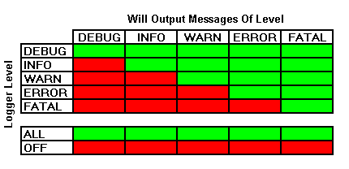

程序中如何使用Logger进行日志输出
……
import com.ubipass.middleware.util.log.*;
………

public class …..{

……..
SystemLogger.debug(“Here is some debug”);
SystemLogger.logger.info("Here is some INFO");
SystemLogger.logger.warn("Here is some WARN");
SystemLogger.logger.error("Here is some ERROR");
SystemLogger.logger.fatal("Here is some FATAL");
……..

}

Thread Pooling

Singleton模式实现的 ThreadPool
package com.ubipass.middleware.util;

import java.util.concurrent.*;

/**
* * Thread Pool used by EMS component * *
*
* @version $Revision$ *
* @author Donghongshan *
* @author $Author$ *
*/
public class ThreadPool {

/** Static Thread Pool by using newCachedThreadPool */
private static ExecutorService executor = null;

/**private constructor*/
private ThreadPool() {
executor = Executors.newCachedThreadPool();
}

/**
* Static method to get an single instance of the ThreadPoll
*/
public static synchronized ExecutorService getInstance() {
if (executor == null)
new ThreadPool();
return executor;

}

/**
* Static method to shutdown the executor immediately, even though there are
* unifinished threads in the pool
*/
public static void shutdownNow() {
executor.shutdownNow();
}

/** Shutdown the executor, but allows the tasks in the executor to complete */
public static void shutdown() {
executor.shutdown();
}

/**
* * judge if the executor has been shutdown,return true shutdown or false
* not * shutdown * *
*
* @return boolean
*/
public static boolean isShutdown() {
return executor.isShutdown();
}

/**
* List all the running threads in the pool to System.out.
*/
public static void listThread() {
ThreadGroup group = Thread.currentThread().getThreadGroup();
ThreadGroup parent = group.getParent();

while (parent != null) {
group = parent;
parent = group.getParent();
}

group.list();
}
}

ThreadPool 使用
……
import com.ubipass.middleware.util.ThreadPool;
import com.ubipass.middleware.exception.*;
……
ExecutorService ex = ThreadPool.getInstance();
……
Runnable r = ……..;

try{
ex.excute(r);
}catch(Exception e){
throw new ThreadExecuteException();
}

Reader Plug-In

AlienPlug-In
package com.ubipass.middleware.PlugIn.Alien;
import java.net.InetAddress;
import com.alien.enterpriseRFID.notify.Message;
import com.alien.enterpriseRFID.notify.MessageListener;
import com.alien.enterpriseRFID.notify.MessageListenerService;
import com.alien.enterpriseRFID.reader.AlienClass1Reader;
import com.alien.enterpriseRFID.tags.Tag;

public class AlienReader implements MessageListener, Reader, Runnable {
private long notifyTime = 0;
private int notifyTrigger;
private String user;
private String password;
private String ip;
private int port;
private int listeningPort;
private String readerID = "";
private String readerName = "";
private AlienClass1Reader reader = new AlienClass1Reader();
private MessageListenerService service = null;
public AlienReader() {
}

public void openReader(String ip, int port, String user, String password)
throws ReaderOperationException {
this.user = user;
this.password = password;
this.ip = ip;
this.port = port;
reader.setNetworkConnection(ip, port);
//Reader的地址和端口,默认为23
reader.setPassword(password);
reader.setUsername(user);
try {
reader.open();
} catch (Exception e) {
throw new ReaderOperationException("Reader Open Exception");
}
}

public void closeReader() throws ReaderOperationException {
try {
if (service != null && service.isRunning()) {
service.stopService();
}
service = null;
if (reader.isOpen()) {
reader.close();
notifyTime = 0;
notifyTrigger = 0;
user = null;
password = null;
ip = null;
port = 0;
listeningPort = 0;
readerID = "";
readerName = "";
}
} catch (Exception e) {
throw new ReaderOperationException("Reader Close Exception");
}
}
public String getReaderID() {
return readerID;
}
public String getReaderName() {
return readerName;
}
public String getReaderIPAddress() {
return ip;
}
public String getReaderPort() {
return port;
}
public String getUserName() {
return user;
}
public void setReaderID(String i) {
readerID = i;
}
public void setReaderName(String string) {
readerName = string;
}
public boolean isReaderWorking() {
return reader.isOpen();
}
public Tag[] getTagList()
throws ReaderOperationException, UnsupportedFeatureException {
com.alien.enterpriseRFID.tags.Tag[] tagList;
com.ubipass.middleware.plugin.Tag[] result;
if (reader.isOpen())
try {
tagList = reader.getTagList();
result = new com.ubipass.middleware.plugin.Tag[tagList.length];
for (int i = 0; i < tagList.length; i++) {
Tag tag = tagList[i];
result[i].setTagID(tag.getTagID());
result[i].setFirstSeenTime(tag.getDiscoverTime());
result[i].setLastSeenTime(
tag.getDiscoverTime() + tag.getPersistTime());
}
} catch (Exception e) {
throw new ReaderOperationException("reader communication fails");
}
return result;
}

public void setListeningPort(int port)
throws ReaderOperationException, UnsupportedFeatureException {
this.listeningPort = port; //设置监听得端口
}

public void setNotifyTime(long time)
throws ReaderOperationException, UnsupportedFeatureException {
notifyTime = time; //设置自动发送得时间
}

public void setNotifyTrigger(int trigger)
throws ReaderOperationException, UnsupportedFeatureException {
notifyTrigger = trigger; //设置触发模式
}

public void setAutoMode(boolean onOrOff)
throws ReaderOperationException, UnsupportedFeatureException {
if (onOrOff) {
if (!reader.isOpen()) {
try {
reader.open(); //先打开Reader才能进行配置
} catch (Exception e) {
throw new ReaderOperationException("Reader Open Exception");
}
}
try {
service = new MessageListenerService(); //Reader必需已经打开
service.setMessageListener(this);
service.setListenerPort(listeningPort);
service.startService();
} catch (Exception e) {
throw new ReaderOperationException("service start Exception");
}
reader.setAntennaSequence("0,1,2,3"); //?
reader.setAcquireMode("Inventory");
//reader.setAcquireMode("Global Scroll");
//Inventory - Perform full inventory of multiple tags.
//Global Scroll - Perform fast search for single tag.
reader.setNotifyAddress(
InetAddress.getLocalHost().getHostAddress(),
listeningPort);
//配置接收端的地址,端口
try {
reader.resetAutoMode();
} catch (Exception e) {
throw new ReaderOperationException("reader communication fails");
}
if (notifyTime == 0) {
if (notifyTrigger == Reader.ADD)
reader.setNotifyTrigger("ADD");
else if (notifyTrigger == Reader.REMOVE)
reader.setNotifyTrigger("REMOVE");
else if (notifyTrigger == Reader.CHANGE)
reader.setNotifyTrigger("CHANGE");
//ADD - a new tag is read and added to the TagList
//REMOVE - a tag is removed from the TagList
//CHANGE - a tag is either added to or removed from the TagList
} else {
reader.setNotifyTime((int) notifyTime);
//自动发送信息的间隔
}
reader.setPersistTime(5);
//默认为10秒,Reader中保存TagID的时间,如超出就会丢失信息
reader.setNotifyFormat(AlienClass1Reader.XML_FORMAT);
//Listener only supports XML messages
try {
reader.setAutoMode(AlienClass1Reader.ON);
} catch (Exception e) {
throw new ReaderOperationException("reader communication fails");
}
//此时Reader已经知道读到Tag信息,将发送到哪里,什么时候发
} else {
try {
reader.resetAutoMode();
} catch (Exception e) {
throw new ReaderOperationException("Reader communication fails");
}
try {
if (service != null && service.isRunning()) {
service.stopService();
}
} catch (Exception e) {
throw new ReaderOperationException("Reader a socket error");
} finally {
service = null;
}
}
}

public void writeTag(String tagInfo)
throws ReaderOperationException,UnsupportedFeatureException {
//?
}

public void run() {
try {
while (service != null && service.isRunning()) {
try {
Thread.sleep(1000);
} catch (Exception e) {
}
}
} catch (Exception e) {
setAutoMode(false);
}
}

public void messageReceived(Message message) {
//处理message
if (message.getReason().equals((Object) notifyTime)) { //??需要测试
//Time模式
for (int i = 0; i < message.getTagCount(); i++) {
Event event = new AlienEvent();
event.setEventType(Event.READ);
event.setReaderID(readerID);
event.setTagID(message.getTag(i).getTagID()); event.setTagReadTime(message.getTag(i).getDiscoverTime());
EMSUtil.addQueue.push(event);
}
} else {
//ADD
if (notifyTrigger == Reader.ADD
|| notifyTrigger == Reader.CHANGE) {
for (int i = 0; i < message.getTagCount(); i++) {
Event event = new AlienEvent();
event.setEventType(Event.ADD);
event.setReaderID(readerID); event.setTagID(message.getTag(i).getTagID()); event.setTagReadTime(message.getTag(i).getDiscoverTime());
EMSUtil.addQueue.push(event);
}
}
//Remove
if (notifyTrigger == Reader.REMOVE
|| notifyTrigger == Reader.CHANGE) {
for (int i = 0; i < message.getTagCount(); i++) {
Event event = new AlienEvent();
event.setEventType(Event.REMOVE);
event.setReaderID(readerID); event.setTagID(message.getTag(i).getTagID());
event.setTagReadTime(
message.getTag(i).getDiscoverTime()
+message.getTag(i).getPersistTime());
EMSUtil.addQueue.push(event);
}
}
}
}
}

package com.ubipass.middleware.PlugIn.Alien;

public class AlienEvent implements Event {
private int eventType;
private String tagID;
private String readerID;
private long readTime;
public int getEventType() {
return eventType;
}
public String getTagID() {
return tagID;
}
public String getReaderID() {
return readerID;
}
public long getTagReadTime() {
return readTime;
}
public void setEventType(int eventType) {
this.eventType = eventType;
}
public void setTagID(String tagID) {
this.tagID = tagID;
}
public void setReaderID(String readerID) {
this.readerID = readerID;
}
public void setTagReadTime(long tagReadTime) {
this.readTime = tagReadTime;
}
}

EMS启动的步骤:
- 打开Reader
调用openReader()方法,只要参数正确,Reader的控制连接将被建立
此时可以用 getTagList()来手工读取TagList,也可以启动自动模式

- 配置并启动自动模式
配置
setListenPort(),setNotifyTime()(READ方式),setNotifyTrigger()(ADD或REMOVE方式)启动
setAutoMode(true)
并启动线程
- 停止自动模式
setAutoMode(false)

- 关闭Reader
停止自动模式
closeReader()

以上都是由EMS控制调用的

Event Management System
Package com.ubipass.middleware.ems

EventQueue
EventQueue 是一个具有固定容量大小的队列，容量大小在系统初始化EventQueue的时候从数据库直接获得，而不需要人工配置。

EventQueue 是java.util.concurrent.ArrayBlockingQueue的实例化变量，用于实际完成Event的FIFO工作，Plug-in负责将Event数据压入EventQueue。

EventLogger
将Event数据存入数据库

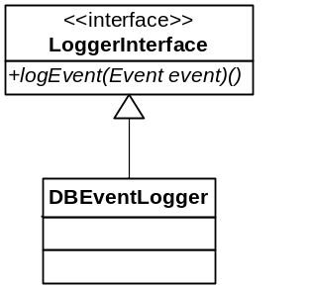

Exceptions
- LogEvent(Event event) 抛出 com.ubipass.middleware.exception.DBOperateException

Method logEvent(Event event)
- 如果传入的Event的EventType是ADD：
将Event直接写入数据库表observaton，removeTime保持为空；
- 如果传入的Event的EventType是REMOVE：
更新与Event的tagID和readerID匹配的数据库observation的最近一条记录，将该Event的发生时间作为记录的RemoveTime更新数据库记录；
- 如果传入Event的EventType是READ:
将Event直接写入数据库，将removeTime设置为0；

Interface Event
Event接口的定义如下:
package com.ubipass.middleware.ems;
public interface Event {
public static final int ADD = 0;
public static final int REMOVE = 1;
public static final int READ = 2;
public int getEventType();
public String getTagID();
public String getReaderID();
public long getTagReadTime();
public void setEventType(int eventType);
public void setTagID(String tagID);
public void setReaderID(String readerID);
public void setTagReadTime(long tagReadTime);
}

接口Event，代表事件队列中的事件
方法名 | 输入参数 | 返回结果 | 说明
getEventType | 无 | 返回事件类型(为ADD, REMOVE及READ之一) | 返回事件类型
getTagID | 无 | 返回标签的ID
getReaderID | 无 | 返回读卡器的ID
getTagReadTime | 无 | 时辍 | 返回检测到该Tag的时间
setEventType |  | 无 | 设置事件类型
  名称 | 描述
  eventID | 事件类型
setTagID |  | 无 | 设置Tag的ID号
  名称 | 描述
  tagID | 标签ID号
setReaderID |  | 无 | 设置产生该消息的读卡器的ID
  名称 | 描述
  readerID | Reader的ID
setTagReadTime |  | 无 | 设置检测到该Tag的时间
  名称 | 描述
  tagReadTime | 时辍

Middleware启动后对EMS进行初始化

产生一个组件初始化的集合类
package com.ubipass.middleware.ems;

import java.util.concurrent.ArrayBlockingQueue;

public class EMSUtil {

private static int queueSize;

public static ArrayBlockingQueue eventQueue;

public static DBEventLogger dbLogger;

public static ReaderList readerList;

static{
int dbQueueSize;
//查询数据库EMS表中queueSize字段的值，并赋值给dbQueueSize变量

eventQueue = new ArrayBlockingQueue(dbQueueSize);
dbLogger = new DBEventLogger();
}
}

Reader 公共数据信息列表
Package com.ubipass.middleware.ems
Class Name: ReaderList
ReaderList 类中的参数private static HashMap readerMap

package com.ubipass.middleware.ems;

import java.util.HashMap;

public class ReaderList {

/**
* readerMap 存储的Key是Reader的ID号，value是Reader的Reference
*/
private static HashMap <String,Reader> readerMap ;

public synchronized boolean stopReader(String readerID) {
/**
* 根据ReaderID查找到对应Reader的Reference
* 调用该Reader的Reference的方法，setAutoMode(false)
* 对应将ReaderMap中该行(key: ReaderID, Value:Reader reference)信息删除
*/
return true/false;
}

public void addReader(Reader reader) {
readerMap.put(reader.getReaderID(), reader);
/**
* 如果该reader的启动模式是自动启动，那么就产生一个Reader的线程
*/
Runnable readerRunnable = (Runnable) reader;
ExecutorService ex ThreadPoll.getInstance();
ex.execute(readerRunnable);
}

static {
/**
* 将数据库Readers表中的所有Reader信息取出
* 将Reader的ID号和该Reader的reference放入readerMap
* 查看每个Reader的启动类型（startup）
* 如果启动类型是自动启动，那么产生一个Reader的线程
*/
}
}

EMS组件之间通讯的线程
EventWorker
- 查找eventQueue中是否有Event数据存在，如果有那么不断将evetnQueue中的Event送给DBEventLogger

Reader线程

Reader线程启动
try{
//实例化一个Reader
Reader readerInstance =(Reader)Class.forName(readers[i].getPluginName()).newInstance();
}cathch(Exception e)
……..
………
If(reader的startupType是自动){
try{
reader. setReaderID (.....);
reader.setUserName(…..);
reader.setPassword(……);
reader.setPersistTime(…..);
reader.openReader(…..);
reader. setEventQueue (EMSUtil.addQueue,EMSUtil.queue);

}catch(ReaderOperationException e)
……..
……...
//Reader放入ReaderList的Map当中
EMSUtil.readerList.addReader(reader);
}

Task Management System

整体结构图
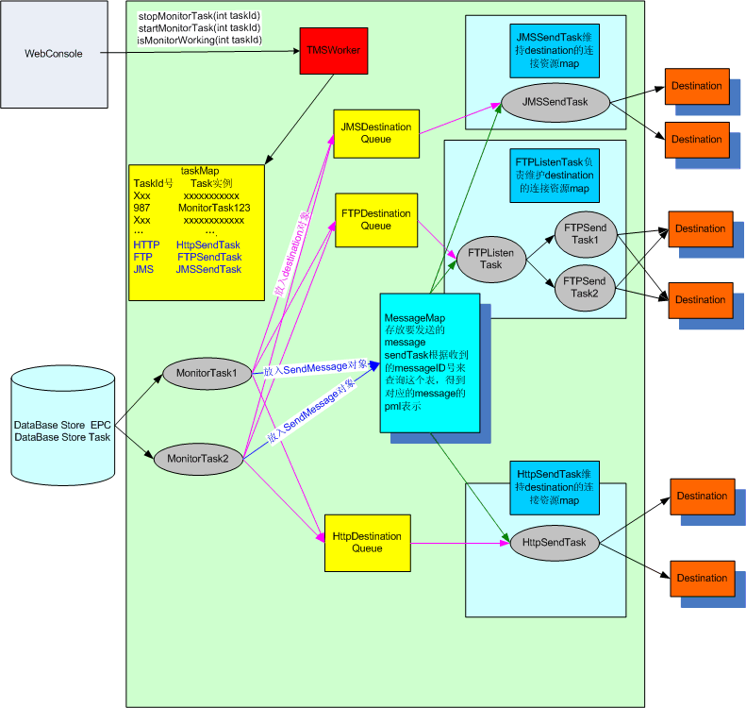

TMSWorker
TMSWorker是TMS的控制端。MainServlet在启动时调用TMSServer的startup方法启动整个TMS系统。在TMS启动后，需要启动一个在数据库里面配置好的monitorTask的时候调用其startMonitorTask方法。在TMS启动后，需要停止一个monitorTask的时候调用其stopMonitorTask方法。在需要停止TMS时，调用safeStop方法。
public class TMSWorker
{
public static Map taskMap;
private static ArrayBlockingQueue<Destination> jmsDestinationQueue;
private static ArrayBlockingQueue<Destination> httpDestinationQueue;
private static ArrayBlockingQueue<Destination> ftpDestinationQueue;
public static Map startUp();
public static boolean safeStop();
public static boolean startMonitorTask(int id);
public static boolean stopMonitorTask(int id);

}

Task
TMS中的Task有2类，Monitor Task 和 Send Task。Monitor Task 代表不同的具体的业务。Monitor Task的任务是根据具体的要求查询数据库或直接访问reader，对查到的信息进行封装，转发到目的队列。Send Task的任务是读取消息队列中的信息，发送给最终的目的地，一共有JMSSendTask， HTTPSendTask，FTPListenTask 3种Send Task，分别代表向JMS，HTTP，FTP发送消息。
Task是一个抽象类，它要求实现Runnable接口，所有的Task必须继承该类。
abstract public class Task implements Runnable
{
private boolean running;
private String taskid;
abstract public safeStop();
public String getTaskId()
public void setTaskId(String id);
}

Task Map
TaskMap是一个HashMap类型的公共数据。在TMS启动时，会把启动起来的Monitor Task和Send Task都放入该map中。整个TMS正常启动完成后有如下的task存在，数据库tasks表中startUp字段为antomatic的Monitor Task，1个JMSSendTask，1个HTTPSendTask， 1个FTPListenTask。MonitorTask的id号就是对应数据库tasks表中的id字段，JMSSendTask，HTTPSendTask， FTPListenTask的id号分别为”JMS”，”HTTP”，”FTP”。TaskMap中的Key为该task的id号，value为该task的reference。
WebConsole通过taskMap由taskId号找到对应的task，然后调用task的safeStop()方法来停止该任务。

SendMessage，SendMessageMap，Destination，DestinationQueue
SendMessage类代表了要发送给异步消息接受服务器的消息的内容，也就是“要发送什么”。由Monitor Task负责产生。messageId由readerId+timestamp产生，messageText是封装成PML格式的字符串，destinationCount代表了要把message发送的目的地的数量（即Destination对象的数量）。
Destination类代表了要发送给异步消息接受服务器的消息的目的地，也就是“向哪里发送”。由Monitor Task负责产生。一个SendMessage可能同时被发往多个Destination。因此SendMessage和Destination是一对多的关系。messageId代表了该Destination要发送的SendMessage的messageId字段，destinationId对应Send Task中存放连接资源的map的key值（参见JMSSendTask, HTTPSendTask, FTPListenTask），fileName表示发往FTPServer和本地磁盘为目的地的时候要存的文件名。
public class SendMessage
{
PrivateString messageId;
PrivateString messageText;
Privateint destinationCount;
PublicString getMessageId();
Publicvoid setMessageId(String messageId);
PublicString getMessageText();
Publicvoid setMessageText(String messageText);
Publicint getCount();
Publicvoid setCount(int count);
Publicsynchronized int decCount(int i);
PublicsendMessage(String messageId,String messageText,
int destinationCount);
}

public class Destination
{
public static final int JMS = 0;
public static final int HTTP = 1;
public static final int FTP = 2;
private String messageId;
private String destinationId;
private String filename;

public String getMessageId();
public void setMessageId(String messageId);
public String getDestinationId();
public void setDestinationId(String destinationId);
public String getFileName();
public void setFileName(String fileName);
public int getType();
public void setType(int type);

public Destination(int type,String messageId,String destinationId,String fileName);
}

- SendMessageMap是一个HashMap,用于存放SendMessage。其中key为message的id号，value为SendMessage对象。
- DestinationQueue是一个ArrayBlockingQueue<Destination>，Queue里面存放的对象是Destination。其作用是缓冲数据（会有大量的Destination对象产生），TMS中共有3个DestinationQueue： JMSDestination，HTTPDestinationQueue，FTPDestinationQueue。
- JMSDestinationQueue里面存放的是发往JMSServer的Destination对象（和某个SendMessage相关联）。一端会有若干个个MonitorTask向该Queue发送Destination对象,另一端有一个JMSSendTask来不断的读取Queue中的内容。
- HTTPDestinationQueue里面存放的是发往HTTPServer的Destination对象（和某个SendMessage相关联）。一端有若干个MonitorTask向该Queue发送Destination对象,另一端有一个HTTPSendTask来不断的读取Queue中的内容。
- FTPDestinationQueue里面存放的是发往FTPServer的Destination对象（和某个SendMessage相关联）。一端有若干个个MonitorTask向该Queue发送Destination对象,另一端有一个FTPListenTask来不断的读取Queue中的内容。
所有MonitorTask产生SendMessage都会被放入SendMessageMap中去。只有所有和该SendMessage相关的Destination被队列取完后才允许从SendMessageMap中删除该SendMessage对象。

FTPListenTask，FTPSendTask
FTPListenTask监听FTPDestinationQueue，读取FTPDestinationQueue中的Destination，根据Destination中的messageId号在SendMessageMap中查找对应的SendMessage。TMS初始化时会根据数据库FTPDestination表中的每一条记录的参数配置分别建立一个FTPSession，代表和不同的FTPServer的连接。FTPListen内部维护一个存放FTPSession类实例的Map--FTPSessionMap，FTPSessionMap的key是数据库中FTPDestination表的id字段，value代表根据该id对应记录所创建的FTPSession。FTPListenTask有一个线程池可供调用，真正向FTPServer上传文件是用放在该线程池中FTPSendTask类实例来做的，以实现FTP的同时向不同的FTPServer上传文件。FTPListenTask当发现FTPDestinationQueue中有数据，并且存放FTPSendTask的线程池有剩余FTPSendTask可供调用。那么就用FTPSendTask根据Destination的destinationId从FTPSessionMap中选择相应的FTPSession，发送对应的SendMessage的MessageText(文件名从Destination的fileName字段获得)。FTPListenTask仅有一个实例存在。每次FTPSendTask发送完（无论成功与否）一个SendMessage时，会调用SendMessage的decCount()方法，然后判断destinationCount是否为0，如果为0就要把该SendMessgae从SendMessageMap中删除。

JMSSendTask
JMSSendTask监听JMSDestinationQueue，读取JMSDestinationQueue中的Destination，根据Destination中的messageId号在SendMessageMap中查找对应的SendMessage。TMS初始化时会根据数据库JMSDestination表中的每一条记录的参数配置分别建立一个JMSSession，代表和不同的JMSServer的连接。JMSSendTask内部维护一个存放JMSSession类实例的Map--JMSSessionMap，JMSSessionMap的key是数据库中JMSDestination表的id字段，value代表根据该id对应记录所创建的JMSSession。JMSSendTask根据Destination的destinationId从JMSSessionMap中选择相应的JMSSession，发送对应的SendMessage的MessageText。JMSSendTaskTask仅有一个实例存在。每次JMSSendTask发送完（无论成功与否）一个SendMessage时，会调用SendMessage的decCount()方法，然后判断destinationCount是否为0，如果为0就要把该SendMessgae从SendMessageMap中删除。

HTTPSendTask
HTTPSendTask监听HTTPDestinationQueue，读取HTTPDestinationQueue中的Destination，根据Destination中的messageId号在SendMessageMap中查找对应的SendMessage。TMS初始化时，会在HTTPSendTask内部建立一个存放HTTPServer相关信息（ip,port,path,username,password）Map--HTTPMap，HTTPMap的key是数据库中HTTPDestination表的id字段，value是一个HTTPDestinationPO对象，该对象包含了ip(对应HTTPDestination表的ip字段)、port(对应HTTPDestination表的port字段)、path(对应HTTPDestination表的path字段)、username(对应HTTPDestination表的username字段)、password(对应HTTPDestination表的password字段)。每个MonitorTask启动时，会构造该task的HTTPDestinationPO对象，并放入HTTPMap中。HTTPSendTask根据Destination的destinationId从HTTPMap中选择相应的HTTPDestinationPO，用发送对应的SendMessage。HTTPSendTask仅有一个实例存在。每次HTTPSendTask发送完（无论成功与否）一个SendMessage时，会调用SendMessage的decCount()方法，然后判断destinationCount是否为0，如果为0就要把该SendMessgae从SendMessageMap中删除。
public class HttpDestinationPO {
private int id;
private int taskId;
private String ip;
private int port;
private String path;
private String username;
private String password;
public int getId() {
return id;
}
public void setId(int id) {
this.id = id;
}
public String getIp() {
return ip;
}
public void setIp(String ip) {
this.ip = ip;
}
public String getPassword() {
return password;
}
public void setPassword(String password) {
this.password = password;
}
public String getPath() {
return path;
}
public void setPath(String path) {
this.path = path;
}
public int getPort() {
return port;
}
public void setPort(int port) {
this.port = port;
}
public int getTaskId() {
return taskId;
}
public void setTaskId(int taskId) {
this.taskId = taskId;
}
public String getUsername() {
return username;
}
public void setUsername(String username) {
this.username = username;
}
}

Monitor Task
Middleware支持异步地以事件触发方式发送包含Tag数据的消息给外部系统。消息采用与SOAP RPC相同的PML格式。消息可以是以文件形式写到本地目录下或FTP到另一台机器，写到TCP Socket中或发送到定义好的JMS的Queue或Topic中。Middleware与外部系统的通信是单方向的，即Middleware只向目的地写数据，而不会接收外部系统的消息。异步消息接口由TMS的Task Manager控制。用户通过Web Console完成Task的配置及手工启动|停止。
不同的Monitortask代表不同的业务要求逻辑， MonitorTask负责按照业务需求查询数据库中的数据，按照一定的格式封装成SendMessage放入SendMessageMap中，把消息的目的地（Destination对象）放去指定的队列中去。应此Monitor内部都维护着3个(代表3种不同的目的地类型jms,http,ftp)arrayList―jmsDestinationList，httpDestinationList，ftpDestinationList.。
jmsDesinationList里存放的是数据库jmsDestination表中所有taskId字段值等于当前monitor task id的记录的id字段。因此jmsDesinationArraylist存放的id号作为key肯定可以在jmsSendTask的jmsSessionMap中找到对应的jmsSession的reference。(待修改)
httpDesinationList里存放该task对应的HttpDestinationPO对象。MonitorTask启动时，会构造该task的HTTPDestinationPO对象，把该对象的reference放入httpDesinationList中，同时也放入HttpSendTask的HTTPMap中。
ftpDesinationList里存放的 是数据库ftpDestination表中所有taskId字段值等于当前monitor task id的记录的id字段。因此ftpDesinationArraylist存放的id号作为key肯定可以在ftpSendTask的ftpSessionMap中找到对应的ftpSession。(待修改)
MonitorTask也需要设置输出队列，即TMSWorker,jmsDestinationQueue,httpDestinationQueue，ftpDestinationQueue。
每个MonitorTask根据数据库表Tasks来初始化，初始化参数从数据库取出来后，都放在对象TaskPO中。
对象TaskPO，代表Task的执行参数（对应数据库表task）
属性名 | 类型 | 说明
taskId | String | 任务的id号。
taskName | String | 任务的名称。
trigger | String | 任务的触发模式。“T”为定时，“A”为新Tag进入Reader检测范围，“R”为Tag移出Reader检测范围，“C”为Reader读到Tag， “E”为Packing By Empty，“I”为Packing By Idle, “N”为Packing By Number。
parameter | Int | 当触发模式为T时，存放定时周期；当触发模式为I时，存放空闲间隔；当触发模式为N时，存放读到Tag的数目。
formatType | String | 输出数据格式，“F”为FULL_PML，“S”为SIMPLIFIED_PML
topLevelIDType | String | PML中第一个ID的格式，“M”为MIDDLEWARE_NAME，“G”为DEVICE_GROUP_NAME
readerIDType | String | PML中ReaderID的格式，“N”为DEVICE_NAME，“I”为DEVICE_ID；
command | String | 命令字符串，用在xml 消息中
runningType | String | 自动任务执行类型， “W”为星期周期，“D”为日周期，NULL或其他为立即不间断执行
startTime | String | 周期性自动任务执行的开始时间。  当runningType=”W”时，startTime的格式为  “WeekDay-HH-MM-SS” 其中WeekDay为”1”,”2”,”3”,”4”,”5”,”6”,”7”中的一个，代表星期天到星期六。HH表示小时，范围是0-23。MM表示分，范围是0-59。SS表示秒，范围是0-59。  当runningType=”D”时，startTime的格式为“HH-MM-SS” 其中HH表示小时，范围是0-23。MM表示分，范围是0-59。SS表示秒，范围是0-59。
endTime | String | 周期性自动任务执行的结束时间。格式同startTime。
encoding | String | 读到EPC/Bar Code的编码格式，“1”为SGTIN-64，“2”为STIN-96，“3”为SSCC-64，“4”为SSCC-96，NULL或其他为无需解码EPC

public abstract class MonitorTask extends Task {

protected int format = 0;
protected String systemName = null;
//destination的总数
protected int destinationCount = 0;
protected TaskPO taskpo = null;
// 存放HttpDestinationPO对象的list
protected List<HttpDestinationPO> httpDestinationList = null;
//HttpDestinationQueue
protected ArrayBlockingQueue<Destination> httpDesinationQueue = null;
//存放sendMessage的Map
protected Map<String, SendMessage> sendMessageMap = null;
//存放该task的device—group的对应关系（用TaskDevicePO）表示
protected Map<String, TaskDevicePO > taskDeviceMap = null;
//构造函数
public MonitorTask(TaskPO taskpo) throws Exception;
//根据pml构造SendMessage对象，放入sendMessageMap
//并构造若干Destination对象，送往各个destinationQueue
public void sendPML(StringBuffer pml) throws Exception;
//判断当前时刻任务是否需要执行
public boolean inSchedule() throws Exception;
}
每个MonitorTask在启动后都要做的工作如下，每个task可能要针对1个或多个reader（由数据库中task表对应），应此下面的工作在一个task工作周期会被执行多次，次数等于配置给该task的reader的个数：
- 查询数据库或直接调用reader接口的方法。
- 把得到的信息封装为PML格式的字符串，并和产生唯一的标识相联系。标识的产生方法为 readerId+”-”+timestamp
- 将PML字符串以及唯一的标识messageId，构造SendMessage对象，其中sendMesage.messageId=唯一的标识，sendMessage.text=PML字符串，sendMessage.destinationCount=jmsDestinationList.size()+httpDesinationList.size()+ftpDesinationList.size()。存入SendMessageMap对象中
- 遍历jmsDesinationArraylist，构造destination对象。其中destination.id=链表中存放的id号，destination.messageId=第3步构造的SendMessage对象的messageId。将构造好的destination对象输入jmsDestinationQueue。
- 遍历httpDesinationArraylist，构造destination对象。其中destination.id=链表中存放的id号，destination.messageId=第3步构造的SendMessage对象的messageId。将构造好的destination对象输入httpDestinationQueue。
- 遍历ftpDesinationArraylist，构造destination对象。其中destination.id=链表中存放的id号，destination.messageId=第3步构造的SendMessage对象的messageId，destination.filename＝第3步构造的SendMessage对象的messageId（自动加上文件后缀.pml）。将构造好的destination对象输入ftpDestinationQueue。

针对不同的触发模式，设计以下的几种Monitor Task （Extends Task）

- NewTagMonitorTask
指定读卡器,当有的新的tag的被检测时,返回检测到的tag信息 。
实现逻辑：
id = Task运行之前查询数据库，得到对应特定device的最大observation的Id号
while (true)
{
if(如果当前时刻 属于任务执行期)
{
Thread.sleep(1000);
For each device do
{
查询observation表，找到对应deviceid并且id号大于id的记录
if(resultSet>0)
构造pml,并发送；
Id重新赋予查询结果中最大的id号

}
}
else
{
//当前时刻不属于任务执行期,线程sleep 30秒
Thread.sleep(30000);
}
//如果 running为false ,那么需要关闭资源，跳出while循环，结束该任务
if(!running)
{
释放资源
break;
}
}

- RemoveTagMonitorTask
指定读卡器,当有的的tag的被移走时,返回检测到的tag信息 。
实现逻辑：
DeviceIdMap用于保存上次查询最大时间得到的Event的所有id号（observation表），key:deviceId, value: id号的List
lastTime=当前系统时间;
while (true)
{
if(如果当前时刻 属于任务执行期)
{
Thread.sleep(1000);
nowTime=当前系统时间;
For each device do
{
resultSet=“select * from observation where removeTime<=nowDate
and removeTime>lastTime order by removeTime”;
if(resultSet>0)
更新lastTime到所有observation的最大RemoveTime值;
检查得到的observation中是否存在DeviceIdMap中的Id号（key：deviceId），如果存在，那么表明该observation已经被打包，不作重新打包;
如果检查后还有需要打包的Observation，那么，重新构造DeviceIdMap中的id List，并挑选出所有需要打包的observation中RemoveTime跟更新后的lastTime相等的observation的id放入List中，用于作下次检查
构造pml,并发送；
}
}
else
{
//当前时刻不属于任务执行期,线程sleep 30秒
Thread.sleep(30000);
}
//如果 running为false ,那么需要关闭资源，跳出while循环，结束该任务
if(!running)
{
释放资源
break;
}
}
- ChangeTagMonitorTask
指定读卡器,当有的新的tag的被检测时或者当有的的tag的被移走时,返回检测 到的或者是 移走的tag信息。
AddTagMoniterTask + RemoveTagMonitorTask

- TimingTagMonitorTask
指定时间间隔和读卡器,返回时间间隔内检测到的所有tag的信息。实现逻辑：
while (true)
{
if(如果当前时刻 属于任务执行期)
{
Thread.sleep(1000);
For each device do
{
调用对应Device的getTagList()
if(list>0)
构造pml,并发送；
}
}
else
{
//当前时刻不属于任务执行期,线程sleep 30秒
Thread.sleep(30000);
}
//如果 running为false ,那么需要关闭资源，跳出while循环，结束该任务
if(!running)
{
释放资源
break;
}
}

- PackingByIdleMonitorTask
指定超时时间t,当超时时间内没有检测到新的Tag时,一次任务周期结束,返回该任务周期内所有检测到的Tag。
实现逻辑：
id = Task运行之前查询数据库，得到对应特定device的最大observation的Id号
List observationLis=new ArrayList();
while (true)
{
if(如果当前时刻 属于任务执行期)
{
Thread.sleep(1000);
For each device do
{
查询observation表，找到对应deviceid并且id号大于id的记录
if(resultSet>0)
构造pml,并发送；
Id重新赋予查询结果中最大的id号；
}
}
}
else
{
//当前时刻不属于任务执行期,线程sleep 30秒
Thread.sleep(30000);
}
//如果 running为false ,那么需要关闭资源，跳出while循环，结束该任务
if(!running)
{
释放资源
break;
}
}

f. PackingTill EmptyMonitorTask
当Reader检测不到任何Tag时,一次任务周期结束,返回该任务周期内所有检测到的Tag。
实现逻辑：
id = Task运行之前查询数据库，得到对应特定device的最大observation的Id号
while (true)
{
if(如果当前时刻 属于任务执行期)
{
Thread.sleep(3000);
nowTime=当前系统时间;
For each device do
{
查询observation表，找到对应deviceid并且id号大于id的记录
if(resultSet>0)
构造pml,并发送；
Id重新赋予查询结果中最大的id号；
}
}
Else
{
//当前时刻不属于任务执行期,线程sleep 30秒
Thread.sleep(30000);
}
//如果 running为false ,那么需要关闭资源，跳出while循环，结束该任务
if(!running)
{
释放资源
break;
}
}

g. PackingByNumberMonitorTask
当Reader读到指定数量的tag后,一次任务周期结束,返回该任务周期内所有检测的Tag。
实现逻辑(1个周期内的业务操作)：
id = Task运行之前查询数据库，得到对应特定device的最大observation的Id号
while (true)
{
if(如果当前时刻 属于任务执行期)
{
Thread.sleep(3000);
nowTime=当前系统时间;
For each device do
{
查找数据库找到对应deviceid，并且observation的id号>id的记录
if(list>0)
将得到的TagList放入deviceID对应的ArrayList
（每个DeviceID对应一个Arraylist，用HashMap实现）
Id重新赋予查询结果中最大的id号
}
if（ArrayList的Size>=packNum）{
构造PML发送
HashMap的DeviceID对应的ArrayList，remove所有发送的tag
}
}
Else
{
//当前时刻不属于任务执行期,线程sleep 30秒
Thread.sleep(30000);
}
//如果 running为false ,那么需要关闭资源，跳出while循环，结束该任务
if(!running)
{
释放资源
break;
}
}

TMSWorker工作流程
TMSWorker.Startup()方法调用后系统内部变化流程
  - 实例化3个队列(FTPDestinationQueue, JMSDestinationQueue, HTTPDestinationQueue)。
  - 实例化唯一一个JMSSendTask实例，启动该task。该实例建立对JMSDestinationQueue的监听，根据数据库jmsDestination表建立JMSSession连接，把建立的JMSSession(作为value)和其对应数据库的socketDestination表中的id字段（作为key）放入JMSSessionMap。如果某个JMSSession建立连接失败,仍然把id作为key放入JMSSessionMap,value赋一个null,等真正有消息要求发送到该JMSServer时，reconnection该JMSServer,如果成功则发送消息并把建立的JMSSession放入map中，如果失败则抛弃消息表明发送失败。每当有要求发送到该JMSServer的消息到来时，仍然尝试reconnection。把JMSSendTask实例reference的和它的id号放入taskMap中，用于控制管理。
  - 实例化唯一一个HTTPSendTask实例，启动该task。。该实例建立对HTTPDestinationQueue的监听，根据数据库httpDestination表中的ip,port,path,username,password构造一个HTTPDestinationPO(作为value)，其对应数据库的httpDestination表中的id字段(作为key)放入httpMap。把（”HTTP”，HTTPSendTask实例的reference）放入taskMap中，用于控制管理。
  - 实例化唯一一个FTPListenTask实例，启动该task。该实例建立对FTPDestinationQueue的监听，根据数据库ftpDestination表建立FTPSession连接，把建立的FTPSession(作为value)和其对应数据库的ftpDestination表中的id字段（作为key）放入FTPSessionMap。如果某个FTPSession建立连接失败,仍然把id作为key放入FTPSessionMap,value赋一个null，等真正有消息要求发送到该FTPServer时，reconnection该FTPServer,如果成功则发送消息并把建立的FTPSession放入map中，如果失败则抛弃消息表明发送失败。每当有要求发送到该FTPServer的消息到来时，仍然尝试reconnection。同时把建立的FTPListenTask的实例和它的id号放入taskMap中，用于控制管理。
  - 根据数据库中task表，（根据参数）实例化相应的MonitorTask类,并为其指定输出队列。启动该task。同时把（id号，MonitorTask实例的reference）放入taskMap中，用于控制管理。
TMSWorker.startMonitorTask(int taskId)方法调用后系统内部变化流程
首先判断taskMap是不是存在key为id的task。如果没有，根据id号查数据库中的task表，根据查到的记录所得的参数，实例化相应的MonitorTask类，并为其指定输出队列。把建立的MonitorTask的reference和它的id号放入taskMap中，用于控制管理。这样taskMap中就多了一条task的记录，对应了该task。然后把该Task启动起来。
TMSWorker.stopMonitorTask(String taskId)方法调用后系统内部变化流程
根据要停止的taskMonitor的id号，在taskMap中得到其reference，调用该reference的safeStop()方法，停止该monitorTask，并且把taskMap中对应的entity移走。
TMSWorker.safeStop()方法调用后系统内部变化流程
首先在taskMap中得到所有monitorTask的reference，调用该reference的safeStop()方法，停止该monitorTask。然后在taskMap中得到JMSSendTask，HTTPSendTask，FTPListenTask的reference。（等待queue里面的数据全部被读完或者立即）调用该reference的safeStop()方法来停止JMSSendTask，HTTPSendTask，FTPListenTask。JMSSendTask，HTTPSendTask，FTPListenTask内部会把和JMS,Http,FTP等服务相连的开放性资源释放掉。

和WebConsole的接口
webConsole与TMS接口
实现类：TMSWorker

启动指定的MonotorTask
方法：public static void startMonitorTask(int taskId) throws Exception;
注：taskId对应数据库stak表的id号。

停止指定的MonotorTask
方法：public static void stopMonitorTask(int taskId) throws Exception;
注：taskId对应数据库stak表的id号。

检查指定的MonotorTask是否启动
方法：public static boolean isMonitorTaskWorking(int taskId);
注：taskId对应数据库stak表的id号。

SOAP RPC

SOAP RPC 结构图
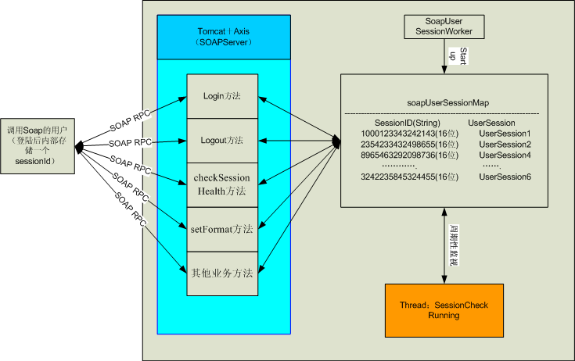

SoapUserSessionWork，UserSession，soapUserSessionMap
SOAP RPC 接口系统中存放着1个Map，命名为soapUserSessionMap。该Map存放soap用户登陆后的sessionId（key）和UserSession对象（entity）。字符串sessionId(根据网卡mac地址和时间产生)；Map的实体为UserSession对象。
public class UserSession
{
private int remaintime=1800;
private boolean isAdmin=false;
private int format=0 ;
private int userId
public static final int FULL_PML=0;
public static final int SIMPLIFIED =1;
public static final int PLAIN_TEXT=2;

public void setRemainTime (int time);
public void setIsAdmin (bollean isAdmin);
public void setFormat (int format);
public void setUserId(int id);
public int getRemainTime ();
public bollean getIsAdmin ();
public int getFormat ();
public int getUserId ();
}

UserSession对象代表了用户回话。remainTime表示会话的存活时间；isaAdmin表示改session是不是由admin建立的；format代表了soap返回的格式（PML，简单PML，简单文本 ）；userId对应数据库users表中的id，代表用户id号。
SoapUserSessionWork负责初始化soapUserSessionMap。由MainServlet调用其startUp方法。

public class SoapUserSessionWorker
{
public static Map soapUserSessionMap ;
public static Map startUp()
{
soapUserSessionMap=new HashMap();
return soapUserSessionMap；
}
}

SessionCheck
SessionCheck是一个线程，由MainServlet启动。负责周期性（30秒）地遍历soapUserSessionMap中所有UserSession的remainTime如果remainTime小于30秒就删除该entity；否则就把该UserSession的remainTime减去30秒，然后放回map中去。

SOAP接口方法
系统登陆/输出格式设定/退出/Session Health Check
1．String login(String user, String password) throws AccessDeniedException, SystemOperationException;
登陆Middleware建立起一个Session，如成功，返回Session的唯一的标识符。外部系统要记住这个Session ID，以后的调用都要给出此参数。
登陆SoapMethod
Public String login(String user, String password) throws AccessDeniedException, SystemOperationException
{
1.根据用户名密码到数据库表中验证合法性
2.如果不是合法用户（用户名密码不匹配；角色不为Admin或ExternalUser）就抛出AccessDeniedException
3.如果是合法用户，那么产生唯一一个sessionId。并构造Usersession对象,放入 soapUserSessionMap
4.返回sessionId
}

2．void logout(String sessionId) throws SystemOperationException;
结束对话。
注销SoapMethod
Public void logout(String sessionId)
{
1.查soapUserSessionMap中是否有对应sessionId的 entity存在
2.如果存在，那么把对应的entity从map中删除
}

3．void setFormat(int format, String sessionId) throws InvalidSessionException, SystemOperationException;
设置返回Tag信息的数据格式：FULL_PML, SIMPLIFIED_PML, PLAIN_TEXT
设置format
void setFormat(int format, String sessionId) throws InvalidSessionException, SystemOperationException)
{
1.查soapUserSessionMap中是否有对应sessionId的entity存在
2.如果不存在就抛出InvalidSessionException
3.如果存在，设置对应的UserSession的format
}

4．void checkSessionHealth(String sessionId) throws InvalidSessionException, SystemOperationException;
当Session在一段时间内(30分钟)没发生任何调用，Middleware会自动结束这个Session即使外部系统没显式地调用logout。如果外部系统还想保留这个Session，就要调用checkSessionHealth，Middleware会重置session timeout。
更新SoapMethod
Public void checkSessionHealth(String sessionId)
{
1.查soapUserSessionMap中是否有对应sessionId的UserSession存在
2.如果不存在就抛出InvalidSessionException
3.如果存在，那么把对应的UserSession的remainTime置为1800秒
}

读Tag信息
这一类的方法共同的一个特点是，每当调用时会根据sessionId号，重置remainTime时间
ReadTag SoapMethod
Public String someReadTagSoapMethod(String readerId ，String sessionId) throws InvalidSessionException, AccessDeniedException, InvalidParameterException, SystemOperationException
{
1.查soapUserSessionMap中是否有对应sessionId的UserSession存在
2.如果不存就抛出InvalidSessionException
3.如果存在，查询数据库判该用户是否有对要求操作的readerId（Reader and/or ReaderGroup）的访问权限，如 果没有权限就抛出AccessDeniedException
4.如果存在，且有对readerId的访问权限，那么把UserSession的remainTime设为1800秒
5.如果有startTime,endTime, idlePeriod等输入参数,则要进行验证,保证 statTime<endTime, idlePeriod>0,如果错误抛出InvalidParameterException
6.执行业务操作，返回结果
}

- String getTagInfo(String readerId, String sessionId) throws InvalidSessionException, AccessDeniedException, SystemOperationException;
返回指定多个Reader and/or ReaderGroup当前读到所有Tag的信息。Reader Group由组名唯一标识，Reader可由它的名字或ID码来识别，它们之间用逗号分隔，如name:reader 1, id:a81934bf00000000, group:group 1。sessionId是以前调用login建立Session时，Middleware返回的本次Session的唯一的标识符。
实现逻辑：调用若干个reader（从公共的数据块中得到reader的若eference）的getTagList()方法就可以实现。

- String getTagInfo(String startTime, String endTime, String readerId, String sessionId) throws InvalidSessionException, AccessDeniedException, InvalidParameterException, SystemOperationException;
返回指定Reader and/or ReaderGroup在startTime到endTime期间读到所有Tag的信息。
实现逻辑：查询observation表，查询条件是addTime<=endTime and (removeTime is null or removeTime>=startTime) or ( removeTime=0 and addTime between startTime and endTime) 。

- String getTagInfoTillEmpty(String startTime, String readerId, String sessionId) throws InvalidSessionException, AccessDeniedException, InvalidParameterException, SystemOperationException;
从startTime开始，到没有任何Tag能被读到为止(没有Tag处在Reader读取范围内)，返回指定Reader and/or ReaderGroup读到的所有Tag的信息。
实现逻辑(针对1个reader)：
long nextTime=startTime;
while(true)
{
result="select Min(removeTime) where (removeTime>nextTime)";
if(result is null)
{
sleep(1 sec);
continue;
}
else
{
nextTime=result.remove;
}

if(nextTime==0)
{
这是bar code
return result="select * where removeTime=nextTime";
}

result="select count(*) where addTime<nextTime and (removeTime>=nextTime or remove is null)";
if(result==0)
{
return result="select * where addTime<nextTime and (removeTime>=startTime or remove is null)";
}
}
- String getTagInfoTillEmpty(String startTime, String endTime, String readerId, String sessionId) throws InvalidSessionException, AccessDeniedException, InvalidParameterException, SystemOperationException;
从startTime开始，到没有任何Tag能被读到或endTime为止，返回指定Reader and/or ReaderGroup读到的所有Tag的信息。
实现逻辑(针对1个reader)：
long nextTime=startTime;
long allTime=startTime;
while(true)
{
if(nextTime>endTime || allTime>endTime)
{
return result="select * where addTime<endTime and (removeTime>=startTime or remove is null)" ;
}

result="select Min(removeTime) where (removeTime>nextTime)";
if(result is null)
{
sleep(1 sec);
allTime=allTime+1 sec;
continue;
}
else
{
nextTime=result.remove;
}

if(nextTime==0)
{
这是bar code
return result="select * where removeTime=nextTime";
}

result="select count(*) where addTime<nextTime and (removeTime>=nextTime or remove is null)";
if(result==0)
{
return result="select * where addTime<nextTime and (removeTime>=startTime or remove is null)";
}
}

- String getTagInfoByIdle(String startTime, long idlePeriod, String readerId, String sessionId) throws InvalidSessionException, AccessDeniedException, InvalidParameterException, SystemOperationException;
从startTime开始，到经过空闲时段(毫秒)后，如果没有新的Tag被检测到为止，返回指定Reader and/or ReaderGroup读到的所有Tag的信息。
实现逻辑(针对1个reader)：
long nextTime=startTime;
result_1="select count(*) where addtime<startTime and (removeTime>=startTime or remove is null)"
if(result_1.count==0)
{
while(true)
{
result_2="select Min(addTime) where addTime>startTime";
if(result_2!=null)
{
nextTime=addTime;
}
else
{
sleep(1 sec);
}
}
}
while(true)
{
nowTime=当前时间；
if(next+idlePeriod>nowTime)
{
sleep(next+idlePeriod-nowTime);//sleep到当前时间
}
result_3="select Max(addTime) where addTime between nextTime and nextTime+idlePeriod";
if(result_3==null)
{
return result_4="select * where addTime<=nextTime
and (removeTime is null or removeTime>=startTime)
or ( removeTime=0 and addTime between startTime and nextTime+idlePeriod)";
}
nextTime=result_3.addTime;
}
- String getTagInfoByIdle(String startTime, String endTime, long idlePeriod, String readerId, String sessionId) throws InvalidSessionException, AccessDeniedException, InvalidParameterException, SystemOperationException;
从startTime开始，到经过空闲时段(毫秒)后，如果没有新的Tag被检测到或endTime为止，返回指定Reader and/or ReaderGroup读到的所有Tag的信息。
long nextTime=startTime;
result_1="select count(*) where addtime<startTime and (removeTime>=startTime or remove is null)"
if(result_1.count==0)
{
while(true)
{
result_2="select Min(addTime) where addTime>startTime";
if(result_2!=null)
{
nextTime=addTime;
}
else
{
sleep(1 sec);
if (超时)
return 结果为空
}
}
}
while(true)
{
nowTime=当前时间；
if(next+idlePeriod>nowTime)
{
sleep(next+idlePeriod-nowTime);
}
if (nextTime>endTime)
return result_4="select * where addTime<=nextTime
and (removeTime is null or removeTime>=startTime)
or ( removeTime=0 and addTime between startTime and endTime)";

result_3="select Max(addTime) where addTime between nextTime and nextTime+idlePeriod";
if(result_3==null)
{
return result_4="select * where addTime<=nextTime
and (removeTime is null or removeTime>=startTime)
or ( removeTime=0 and addTime between startTime and nextTime+idlePeriod)";
}
nextTime=result_3.addTime;
}

- String getTagEvent(String startTime, String endTime, int triggerType, String readerId, String sessionId) throws InvalidSessionException, AccessDeniedException, InvalidParameterException, SystemOperationException;
返回指定Reader and/or ReaderGroup在startTime到endTime期间所有发生Tag Event的信息。triggerType可为预定义常数之一：ADD、REMOVE或CHANGE。
实现逻辑：查询observation表，
triggerType为ADD时，条件是addTime<=endTime and addtime>=startTime
triggerType为REMOVE时，条件是removeTime<=endTime and removeTime >=startTime
triggerType为CHANGE时，条件是addTime<=endTime and (removeTime is null or removeTime >=startTime) or ( removeTime=0 and addTime between startTime and nowTime)。

写Tag
只能在Operator建立的session中，才能调用writeTag。
- String writeTag(String tagID, String readerId, String sessionId) throws InvalidSessionException, AccessDeniedException, SystemOperationException;
通过指定的一个Reader写tagID。
String writeTag(String tagID, String readerId, String sessionId) throws InvalidSessionException, AccessDeniedException, SystemOperationException
{
1.查soapUserSessionMap中是否有对应sessionId的UserSession存在
2.如果不存就抛出InvalidSessionException
3.如果存在，查询数据库判改该用户是否有对要求操作的readerId（Reader and/or ReaderGroup）的访问权限，如 果没有权限就抛出AccessDeniedException
4.如果存在，且有对readerId的访问权限，那么把UserSession的remainTime设为1800秒
5.执行业务操作，返回结果
}

任务控制
这一类的方法共同的一个特点是，每当调用时会根据sessionId号，重置remainTime时间;另一个特点是只能在Administrator建立的session中，才能执行任务控制方法。
1．void startTask(String taskName, String sessionId) throws InvalidSessionException, AccessDeniedException, SystemOperationException;
根据taskId号，启动一个任务。
Public String startTask(String taskName, String sessionId) InvalidSessionException, AccessDeniedException, SystemOperationException
{
1.查soapUserSessionMap中是否有对应sessionId的UserSession存在
2.如果不存就抛出InvalidSessionException
3.如果存在，查询数据库判该用户是否有对要求操作的readerId（Reader and/or ReaderGroup）的访问权限，如 果没有权限就抛出AccessDeniedException
4.如果存在，且有对readerId的访问权限，那么把UserSession的remainTime设为1800秒
5.执行业务操作，返回结果
}

- void stopTask(String taskName, String sessionId) throws InvalidSessionException, AccessDeniedException, SystemOperationException;
根据taskId号，停止一个任务。
Public String stopTask(String taskName, String sessionId) InvalidSessionException, AccessDeniedException, SystemOperationException
{
1.查soapUserSessionMap中是否有对应sessionId的UserSession存在
2.如果不存就抛出InvalidSessionException
3.如果存在，查询数据库判该用户是否有对要求操作的readerId（Reader and/or ReaderGroup）的访问权限，如 果没有权限就抛出AccessDeniedException
4.如果存在，且有对readerId的访问权限，那么把UserSession的remainTime设为1800秒
5.执行业务操作，返回结果
}

Http Command Interface
首先定义一个servlet类，该Servlet的功能是首先判断Http请求的IP(用户)是否合法，如果不合法，那么就返回Status code:401 Unauthorized；如果合法，那么就做下面的四步操作
(1)接收到xml command后立即返回 “HTTP 200 OK ” 的response给客户端
(2)解析Command XML，得到 ReaderID, Tag Coding Type, tagID
(3)发指令给标签打印机，打印标签
(4)发送打印结果的xml message 给发送命令的Client

public class CmdServlet extends HttpServlet {
private static final long serialVersionUID = 1L;
/*
* receive xml command file and do bussiness logic
* (1) send Message "HTTP 200 OK" response to client
* (2) parse the xml input stream, get readerID, tag code type, tagID
* (3) call the reader to write tag, then get reader's response
* (4) post XML message to the command sending client
*/
//parse the xml input stream, get readerID, tag code type, tagID
......
......

// call the printer to print a tag
......
......
// post XML message to http command client
......
查看HttpCmdReplyList中是否存在客户端的ip，如果有的话，则得到该ip相对应的所有信息，并将printer的打印结果生成xml String ，然后发送xml到command client的目的地
......

}
}

在Middleware的web.xml里面添加如下语句，定义访问CmdServlet的URL ：
<servlet>
<servlet-name>httpcmd</servlet-name>
<!--http command servlet-->
<servlet>
<servlet-name>httpcmd</servlet-name>
<servlet-class>com.ubipass.middleware.web.command.CmdServlet</servlet-class>
<!-- <security-role-ref>
<role-name>AdminRole</role-name>
<role-link>Administrator</role-link>
</security-role-ref>
<security-role-ref>
<role-name>OperatorRole</role-name>
<role-link>Operator</role-link>
</security-role-ref>
-- >
</servlet>

<servlet-mapping>
<servlet-name>httpcmd</servlet-name>
<url-pattern>/httpcmd</url-pattern>
</servlet-mapping>

AII 作为Client可以通过访问Http://middlewareIP:port/httpcmd 超级链接来向Middleware发送Http命令

HttpCmdReplyList：
在内存中保存一个HttpCommandReply的HashMap，该Map是在MainServlet启动的时候加载到内存的，作用是方便CmdServlet 执行对Client 进行Response的时候检查发送命令的IP地址是否合法，如果合法，那么获得对应Client IP的其它连接信息，并回送XML返回信息。

public class HttpCmdReplyList {
private static ArrayList<HttpCommandReplyPO> httpList = null;

private static HashMap<String,HttpCommandReplyPO> httpReplyMap = null;
/**
* get httpList via HttpCommandReplyDAO
*/
public static void loadHttpList() {
……得到数据库表HttpCommandReply中的所有记录，并将每个记录放入HashMap
}

/**
* get a commandReplyPo from httpList,if list does not contain one,
* return null
*
* @return HttpCommandReplyPO
*/
public static HttpCommandReplyPO getHttpReplyInfo(String ip) {
if(httpReplyMap.containsKey(ip)){
return httpReplyMap.get(ip);
}
return null;
}
}

HttpCmdReplyList 在 MainServlet启动的时候就会调用HttpCmdReplyList.loadHttpList() 将所有的HttpCommandReply 的记录放入内存的HashMap中

public class MainServlet extends HttpServlet {
public void init() {
......
HttpCmdReplyList.loadHttpList();
......

Software Libraries and Tools

Database Server and JDBC Driver
Middleware supports the following database servers: Oracle 8/9i/10g, SQL Server 2000 and MySQL 4.1.
Oracle 10g JDBC driver: http://www.oracle.com/technology/software/tech/java/sqlj_jdbc/index.html;
SQL Server 2000 driver for JDBC SP3: http://www.microsoft.com/downloads/details.aspx?FamilyID=07287B11-0502-461A-B138-2AA54BFDC03A&displaylang=en
MySQL Connector/J 3.0: http://www.mysql.com/products/connector/j/

Web Server
Apache Tomcat 5.5.4 (Tomcat 5.0.28) is used as web server: http://jakarta.apache.org/tomcat/index.html.

SOAP Engine
Apache Axis 1.2RC2 is used as SOAP engine: http://www.apache.org/dyn/closer.cgi/ws/axis.

Web MVC Framework
Apache Struts 1.2.4 is used as web MVC framework: http://struts.apache.org/.

Logging Utility
Apache Log4J 1.2.9 is used as logging utility: http://logging.apache.org/log4j/.

JSTL Taglib
Apache Standard Taglib 1.1.2 is used as JSTL 1.1 implementation: http://jakarta.apache.org/taglibs/index.html.

Java FTP Library
Apache Commons Net 1.3 is used as FTP library: http://jakarta.apache.org/commons/net/.

JMS Provider
ActiveMQ 1.4 is used as JMS provider: http://activemq.org/.

Alien RFID Reader Library
Alien RFID Reader Developers Kit Java Library is used to program Alien plug-in.

